Image Processing Application – Spring 2021

Lecturer: Professor Lee Guee Sang

Student: Le Hoai Duy – 218493

**Homework 7**

1. Code the noise generator of AWGN, uniform distribution noise, salt, and pepper noise.

1) For the image in the textbook and Lena image, apply these noise generators to create noisy images, probably with different parameters.

**Code:**

import os

import cv2

import numpy as np

from matplotlib import pyplot as plt

import random

def noise_gaussian(img, variance = 100):

    gaussian_noise = img.copy()

    cv2.randn(gaussian_noise, 0, variance**0.5)

    return cv2.add(img,gaussian_noise)

def noise_uniform(img, low=0, high=100):

    uniform_noise = img.copy()

    cv2.randu(uniform_noise,low,high)

    return cv2.add(img,uniform_noise)

def noise_salt_pepper(img, noise_type, prob=0.1):

    if noise_type == "salt":

        salt_noise = img.copy()

        for i in range (int(img.shape[0]*img.shape[1]*prob)):

            y_coord=random.randint(0, img.shape[0] - 1)

            x_coord=random.randint(0, img.shape[1] - 1)

            salt_noise[y_coord][x_coord] = 255

        return salt_noise

    elif noise_type == "pepper":

        pepper_noise = img.copy()

        for i in range (int(img.shape[0]*img.shape[1]*prob)):

            y_coord=random.randint(0, img.shape[0] - 1)

            x_coord=random.randint(0, img.shape[1] - 1)

            pepper_noise[y_coord][x_coord] = 0

        return pepper_noise

if __name__ == "__main__":

    image = cv2.imread('./tb1.png',cv2.IMREAD_GRAYSCALE)

    gaussian1 = noise_gaussian(image,1000)

    gaussian2 = noise_gaussian(image,2000)

    uniform1 = noise_uniform(image,10,50)

    uniform2 = noise_uniform(image,20,100)

    salt1 = noise_salt_pepper(image,"salt",0.1)

    salt2 = noise_salt_pepper(image,"salt",0.3)

    pepper1 = noise_salt_pepper(image,"pepper",0.1)

    pepper2 = noise_salt_pepper(image,"pepper",0.3)

    fig, axes = plt.subplots(ncols=2, nrows=2,figsize=(20, 20))

    ax0, ax1, ax2, ax3 = axes.flat

    ax0.imshow(gaussian1, cmap = 'gray')

    ax0.set_title('Image corrupted by AWGN with variance = 1000', fontsize=24)

    ax0.axis('off')

    ax1.imshow(gaussian2, cmap = 'gray')

    ax1.set_title('Image corrupted by AWGN with variance = 2000', fontsize=24)

    ax1.axis('off')

    ax2.imshow(uniform1, cmap = 'gray')

    ax2.set_title('Image corrupted by uniform noise with \n low_intensity = 20, high_intensity = 100', fontsize=24)

    ax2.axis('off')

    ax3.imshow(uniform2, cmap = 'gray')

    ax3.set_title('Image corrupted by uniform noise with \n low_intensity = 50, high_intensity = 200', fontsize=24)

    ax3.axis('off')

    fig.savefig("D:/result_HW7_1.png",bbox_inches='tight')

    fig, axes = plt.subplots(ncols=2, nrows=2,figsize=(20, 20))

    ax0, ax1, ax2, ax3 = axes.flat

    ax0.imshow(salt1, cmap = 'gray')

    ax0.set_title('Image corrupted by salt noise with prob. = 0.1', fontsize=24)

    ax0.axis('off')

    ax1.imshow(salt2, cmap = 'gray')

    ax1.set_title('Image corrupted by salt noise with prob. = 0.3', fontsize=24)

    ax1.axis('off')

    ax2.imshow(pepper1, cmap = 'gray')

    ax2.set_title('Image corrupted by pepper noise with prob. = 0.1', fontsize=24)

    ax2.axis('off')

    ax3.imshow(pepper2, cmap = 'gray')

    ax3.set_title('Image corrupted by pepper noise with prob. = 0.3', fontsize=24)

    ax3.axis('off')

    fig.savefig("D:/result_HW7_2.png",bbox_inches='tight')

**Result:**

Original image in text book

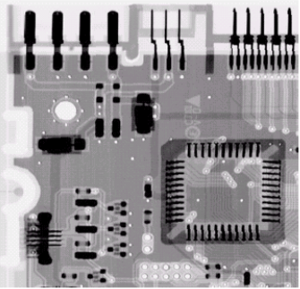

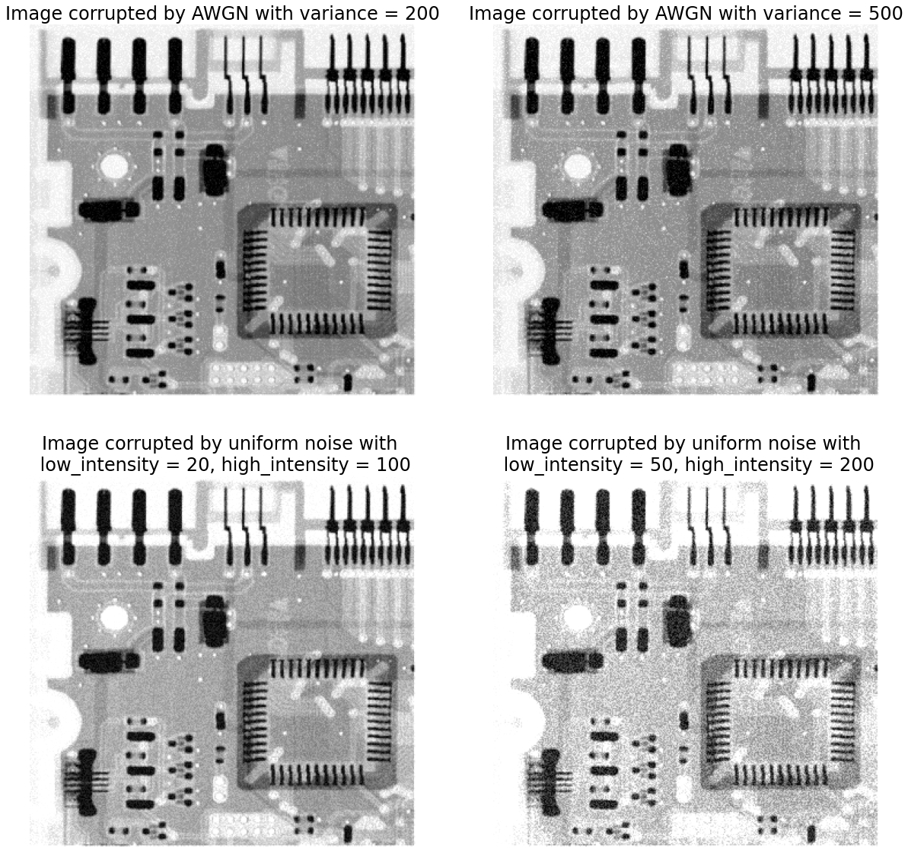

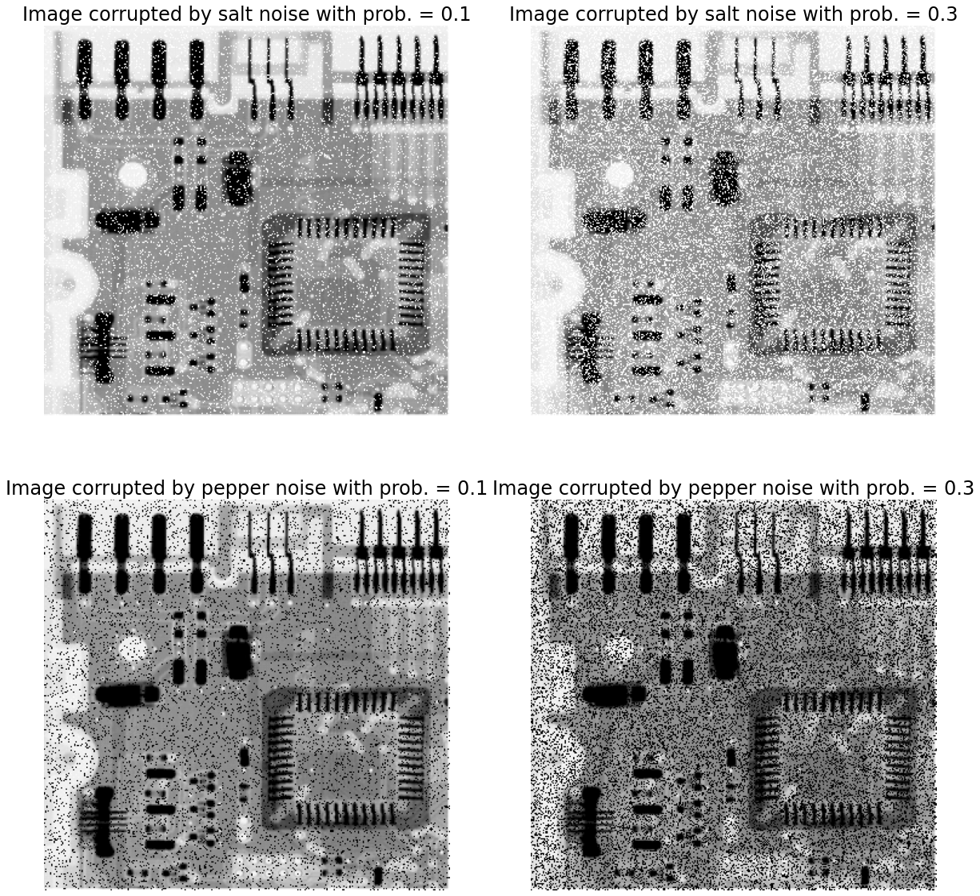

Original image

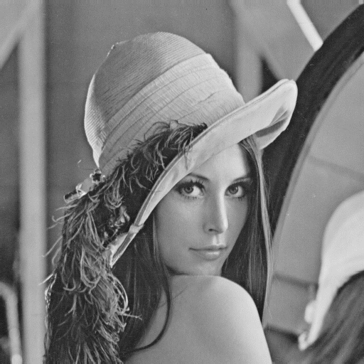

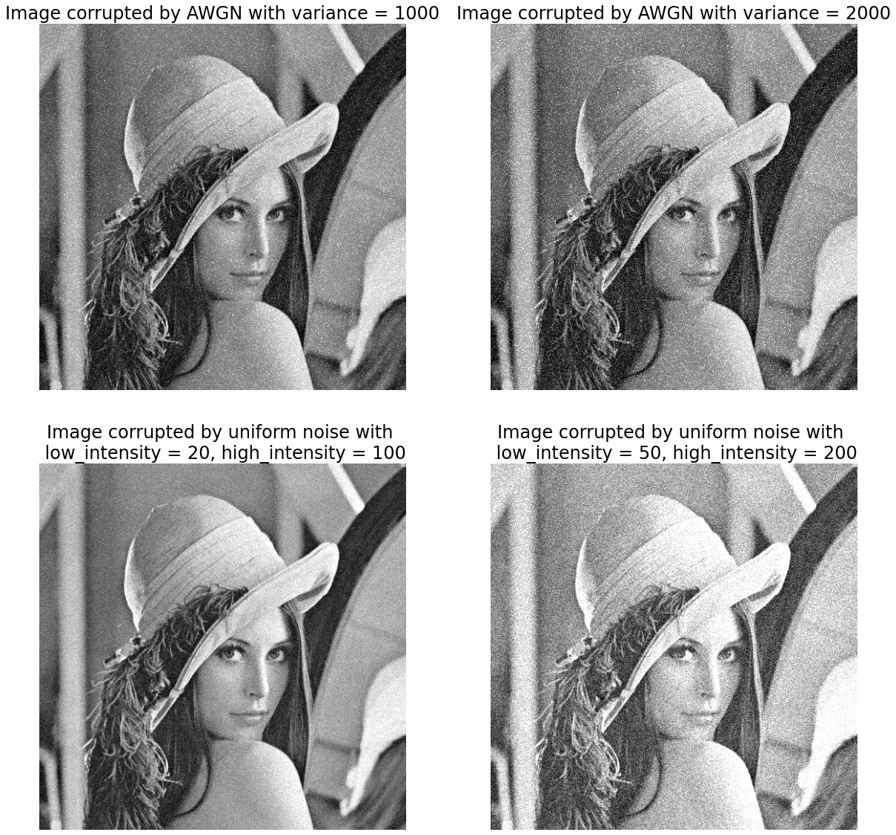

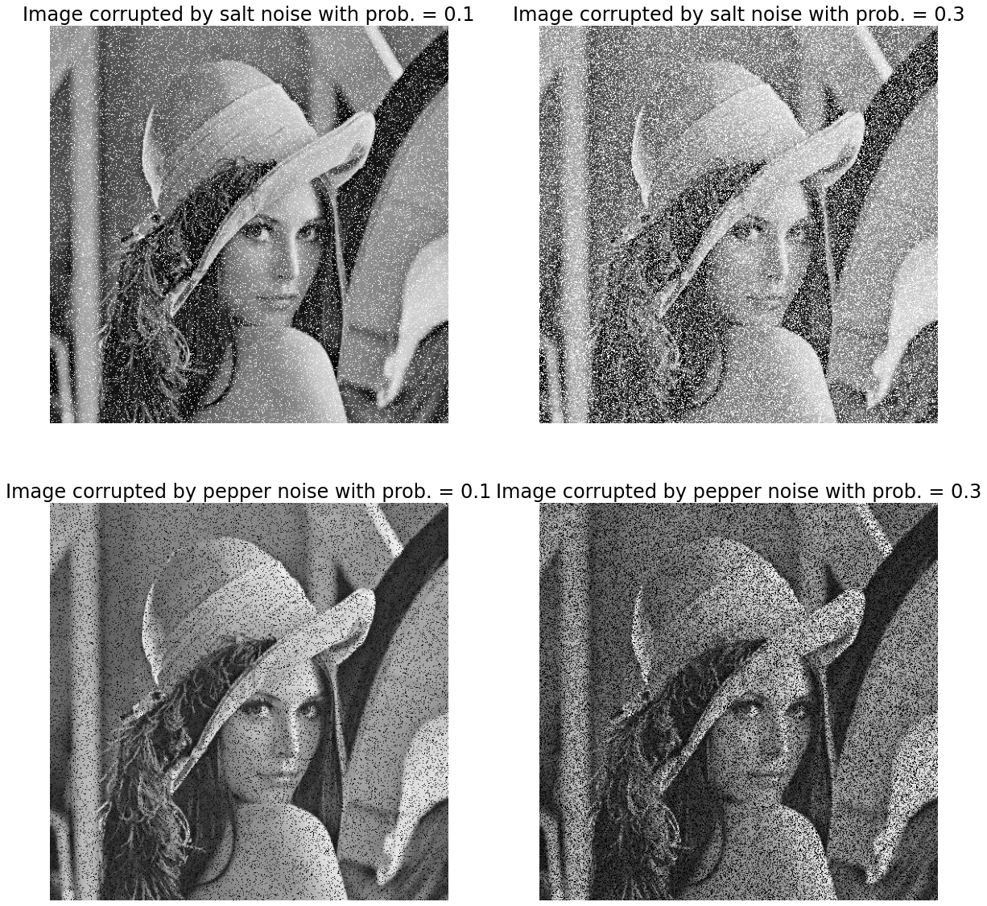

2) Restore the noisy images at your best. Display the results and explain what happened.

**Code:**

image = cv2.imread('./tb1.png',cv2.IMREAD_GRAYSCALE)

gaussian1 = noise_gaussian(image,200)

salt1 = noise_salt_pepper(image,"salt",0.1)

pepper1 = noise_salt_pepper(image,"pepper",0.1)

#Geometric mean filter:

def G_mean(img,kernel_size):

    G_mean_img = np.ones(img.shape)

    k = int((kernel_size-1)/2)

    for i in range(img.shape[0]):

        for j in range(img.shape[1]):

            if i <k or i>(img.shape[0]-k-1) or j <k or j>(img.shape[1]-k-1):

                G_mean_img[i][j]=img[i][j]

            else:

                for n in range(kernel_size):

                    for m in range(kernel_size):

                        G_mean_img[i][j] *=np.float(img[i-k+n][j-k+m])

                G_mean_img[i][j] = pow(G_mean_img[i][j],1/(kernel_size*kernel_size))

    G_mean_img = np.uint8(G_mean_img)

    return G_mean_img

#Contraharmonic mean filter filter:

def HT_mean(img,kernel_size,Q):

    G_mean_img = np.zeros(img.shape)

    k = int((kernel_size-1)/2)

    for i in range(img.shape[0]):

        for j in range(img.shape[1]):

            if i <k or i>(img.shape[0]-k-1) or j <k or j>(img.shape[1]-k-1):

                G_mean_img[i][j]=img[i][j]

            else:

                result_top = 0

                result_down = 0

                for n in range(kernel_size):

                    for m in range(kernel_size):

                        if Q>0:

                            result_top +=pow(np.float(img[i-k+n][j-k+m]),Q+1)

                            result_down +=pow(np.float(img[i-k+n][j-k+m]),Q)

                        else:

                            if img[i-k+n][j-k+m]==0:

                                G_mean_img[i][j] = 0

                                break

                            else:

                                result_top +=pow(np.float(img[i-k+n][j-k+m]),Q+1)

                                result_down +=pow(np.float(img[i-k+n][j-k+m]),Q)

                    else:

                        continue

                    break

                else:

                    if result_down !=0:

                        G_mean_img[i][j] = result_top/result_down

    G_mean_img = np.uint8(G_mean_img)

    return G_mean_img

gaussian_restore = G_mean(gaussian1,kernel_size = 3)

fig, axes = plt.subplots(ncols=2, nrows=1,figsize=(20, 10))

ax0, ax1 = axes.flat

ax0.imshow(gaussian1, cmap = 'gray')

ax0.set_title('Image corrupted by AWGN with variance = 200', fontsize=24)

ax0.axis('off')

ax1.imshow(gaussian_restore, cmap = 'gray')

ax1.set_title('Image restored by 3x3 geometric \n mean filter', fontsize=24)

ax1.axis('off')

fig.savefig("D:/result_HW7_3.png",bbox_inches='tight')

**Results:**

Original image



Noises are removed

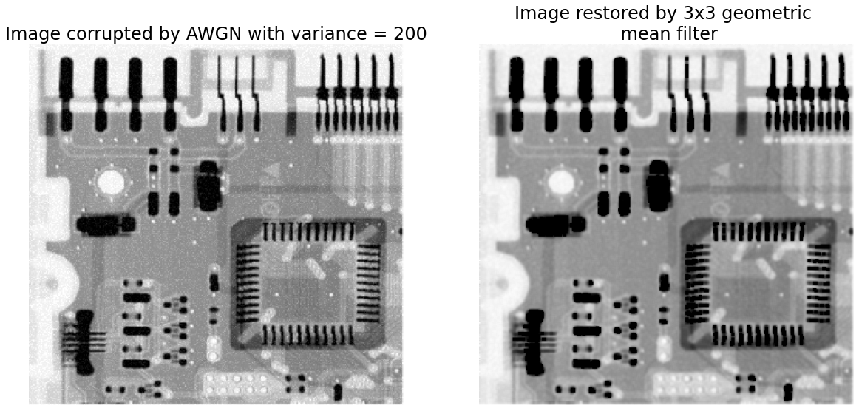

Original image



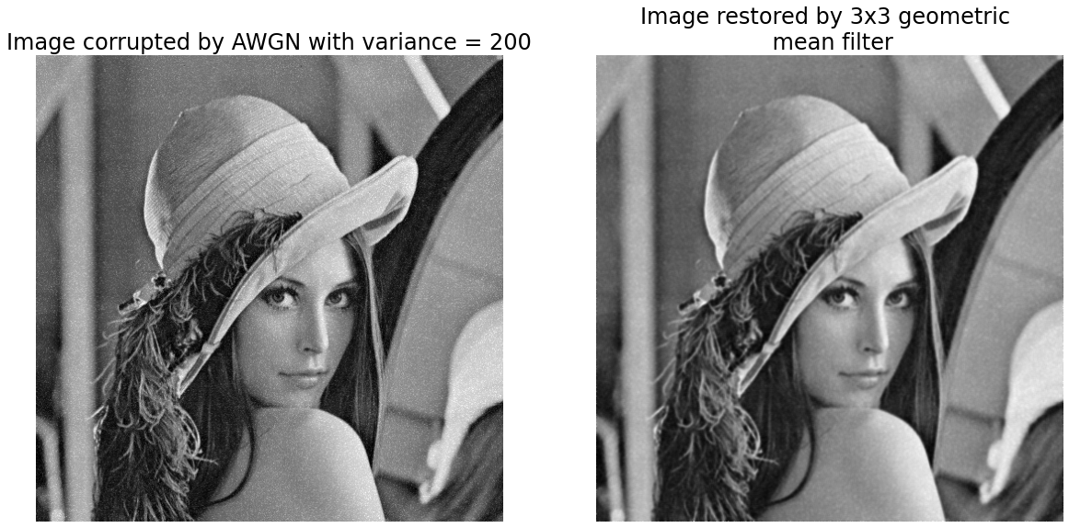

**Code:**

salt_restore = HT_mean(salt1,kernel_size = 3, Q = -1.5)

fig, axes = plt.subplots(ncols=2, nrows=1,figsize=(20, 10))

ax0, ax1 = axes.flat

ax0.imshow(salt1, cmap = 'gray')

ax0.set_title('Image corrupted by salt noise with prob. = 0.1', fontsize=24)

ax0.axis('off')

ax1.imshow(salt_restore, cmap = 'gray')

ax1.set_title('Image restored by 3x3 contraharmonic \n mean filter with Q = -1.5', fontsize=24)

ax1.axis('off')

fig.savefig("D:/result_HW7_4.png",bbox_inches='tight')

**Result:** salt noises are removed with negative Q

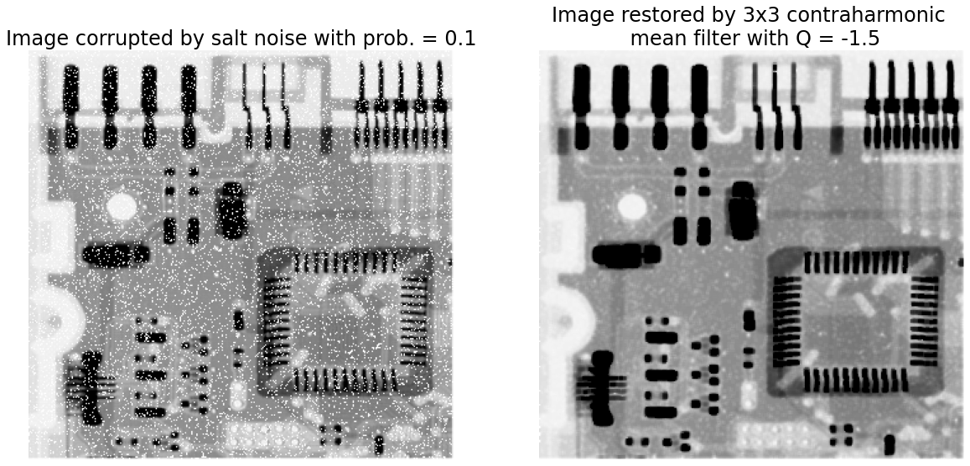

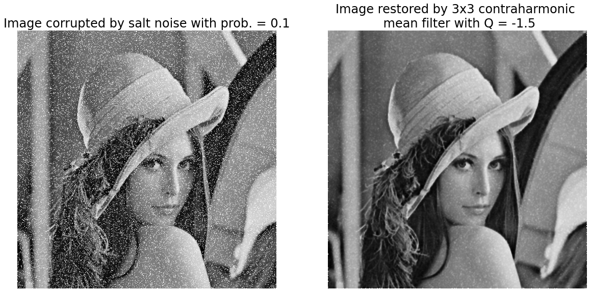

**Code:**

pepper_restore = HT_mean(pepper1,kernel_size = 3, Q = 1.5)

fig, axes = plt.subplots(ncols=2, nrows=1,figsize=(20, 10))

ax0, ax1 = axes.flat

ax0.imshow(pepper1, cmap = 'gray')

ax0.set_title('Image corrupted by pepper noise with prob. = 0.1', fontsize=24)

ax0.axis('off')

ax1.imshow(pepper_restore, cmap = 'gray')

ax1.set_title('Image restored by 3x3 contraharmonic \n mean filter with Q = 1.5', fontsize=24)

ax1.axis('off')

fig.savefig("D:/result_HW7_5.png",bbox_inches='tight')

**Result:** pepper noises are removed with positive Q

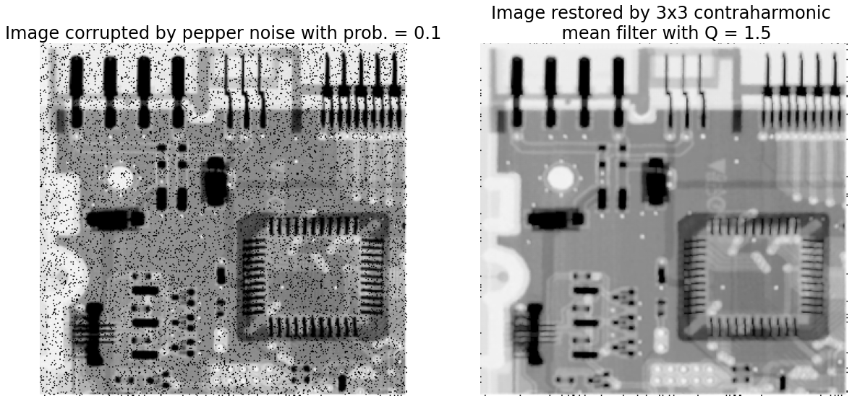

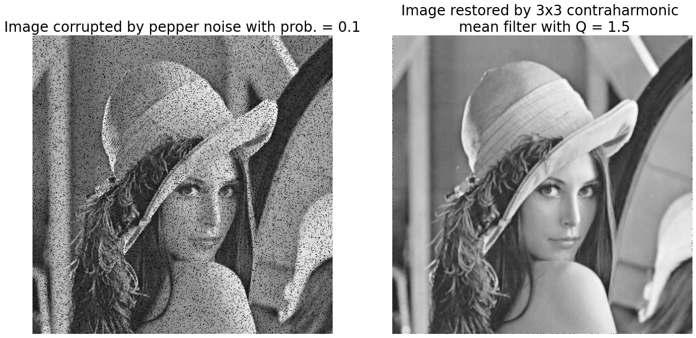

2. For the images in the text book (airplane images and the book cover with camera movement) and another sample, try the turbulence model to re-generate the images in the textbook. Explain the meaning of D0 parameter and display other results with different parameters. What are the differences? Conclude your experiment.

**Code:**

import os

import cv2

import numpy as np

from numpy import fft

from matplotlib import pyplot as plt

import math

def fft_distances(m, n):

    u = np.array([i if i <= m / 2 else m - i for i in range(m)],

                 dtype=np.float32)

    v = np.array([i if i <= n / 2 else n - i for i in range(n)],

                 dtype=np.float32)

    u.shape = m, 1

    ret = u * u + v * v

    return np.fft.fftshift(ret)

def turbulance_model(img,k = 0.0025):

    #compute fft and fft_shift

    img_fft = np.fft.fft2(img, axes=(0,1))

    img_fftshift = np.fft.fftshift(img_fft)

    #compute mask filter

    duv = fft_distances(*img_fftshift.shape[:2])

    filter_mat =np.exp(-k * (duv**(5/6)))

    #apply filter by multiple filter_mat and fftshift

    dst_fftshift = np.multiply(img_fftshift,filter_mat)

    #compute inverse fft

    dst_ifftshift = np.fft.ifftshift(dst_fftshift)

    dst_ifft = np.fft.ifft2(dst_ifftshift)

    #combine complex real and imaginary components to form (the magnitude for) the original image again

    dst = np.abs(dst_ifft)

    turbulance_img = cv2.normalize(dst, None, alpha=0, beta=255, norm_type=cv2.NORM_MINMAX, dtype=cv2.CV_8U)

    return turbulance_img

def motion_process(image_size, motion_angle):

    psf=np.zeros(image_size)

    center_position=(image_size [0] -1)/2

    slope_tan=math.tan (motion_angle * math.pi/180)

    slope_cot=1/slope_tan

    if slope_tan<= 1:

        for i in range (15):

            offset=round (i * slope_tan) #((center_position-i) * slope_tan)

            psf [int(center_position + offset), int (center_position-offset)]=1

        return psf/psf.sum () #normalize the brightness of the point spread function

    else:

        for i in range (15):

            offset=round (i * slope_cot)

            psf [int(center_position-offset), int(center_position + offset)]=1

    return psf/psf.sum ()

#Motion blur the picture

def make_blurred(input, psf, eps):

    input_fft=fft.fft2 (input) #Fourier transform a two-dimensional array

    psf_fft=fft.fft2(psf) + eps

    blurred=fft.ifft2(input_fft * psf_fft)

    blurred=np.abs(fft.fftshift (blurred))

    return blurred

img = cv2.imread('./tb3.png',cv2.IMREAD_GRAYSCALE)

turbulance_img1 = turbulance_model(img, k=0.0025)

turbulance_img2 = turbulance_model(img, k=0.001)

turbulance_img3 = turbulance_model(img, k=0.00025)

fig, axes = plt.subplots(ncols=2, nrows=2,figsize=(20, 20))

ax0, ax1, ax2, ax3 = axes.flat

ax0.imshow(img, cmap = 'gray')

ax0.set_title('Original image', fontsize=24)

ax0.axis('off')

ax1.imshow(turbulance_img1, cmap = 'gray')

ax1.set_title('Severe turbulence k = 0.0025', fontsize=24)

ax1.axis('off')

ax2.imshow(turbulance_img2, cmap = 'gray')

ax2.set_title('Mild turbulence k = 0.001', fontsize=24)

ax2.axis('off')

ax3.imshow(turbulance_img3, cmap = 'gray')

ax3.set_title('Low turbulence k = 0.00025', fontsize=24)

ax3.axis('off')

fig.savefig("D:/result_HW7_6.png",bbox_inches='tight')

image=cv2.imread ("./tb4.png",0)

img_h=image.shape [0]

img_w=image.shape [1]

#Perform motion blur

psf=motion_process((img_h, img_w), 300)

blurred=np.abs(make_blurred (image, psf, 1e-2))

fig, axes = plt.subplots(ncols=2, nrows=1,figsize=(20, 10))

ax0, ax1 = axes.flat

ax0.imshow(image, cmap = 'gray')

ax0.set_title('Original image', fontsize=24)

ax0.axis('off')

ax1.imshow(blurred, cmap = 'gray')

ax1.set_title('Motion blurred image', fontsize=24)

ax1.axis('off')

fig.savefig("D:/result_HW7_7.png",bbox_inches='tight')

**Result:** k is a constant that depends on the nature of the turbulence. The higher the K, the more blurred the image will be.

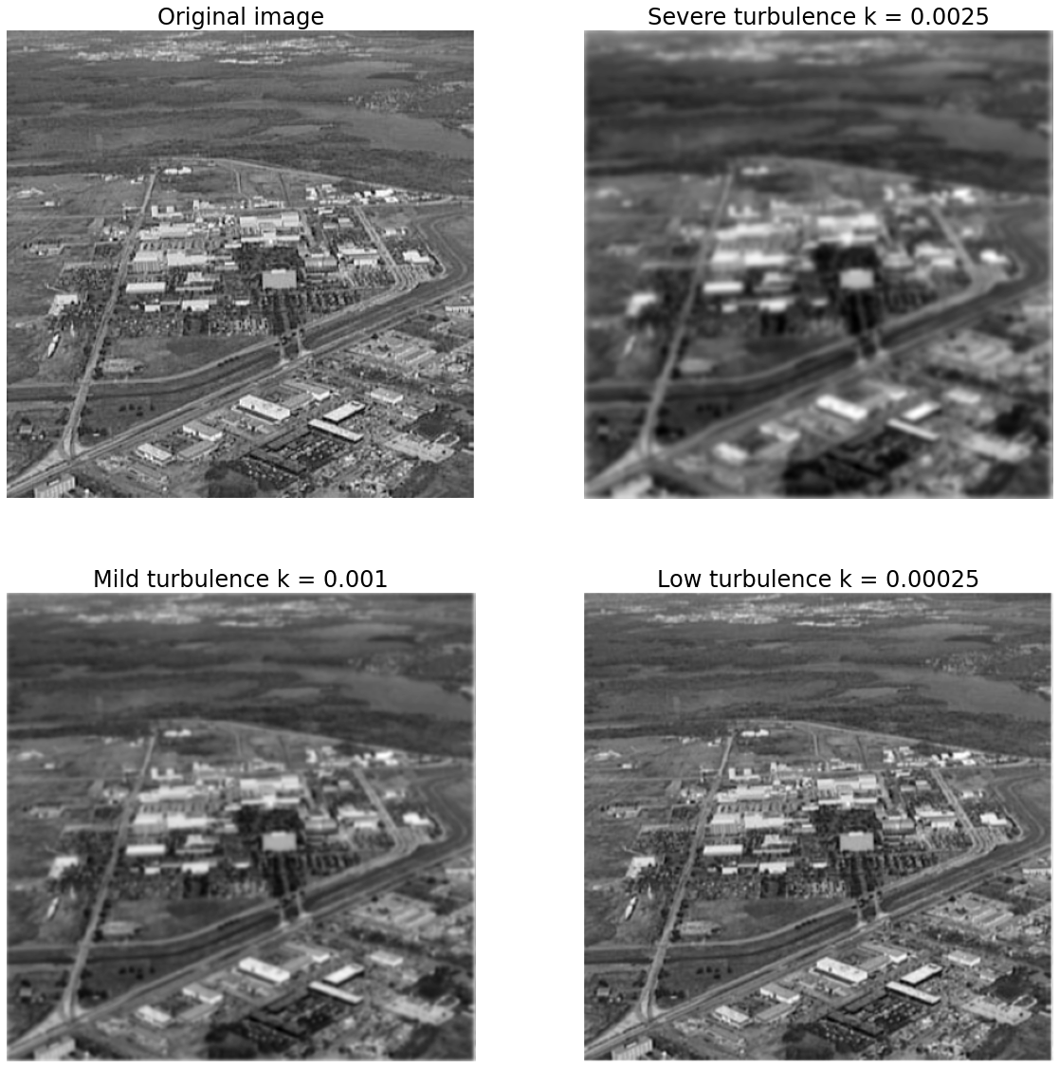

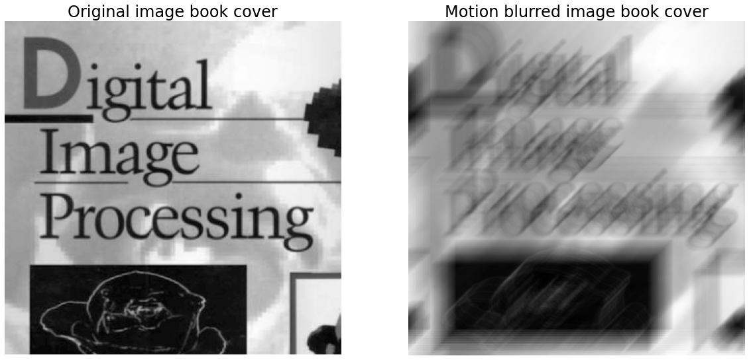

3. Try Wiener filter to do the same thing. Present your point or message in the experiment with a detailed explanation:

**Code:**

import numpy as np

from numpy import fft

import math

import cv2

#Simulation motion blur

def motion_process(image_size, motion_angle):

    psf=np.zeros(image_size)

    center_position=(image_size [0] -1)/2

    slope_tan=math.tan (motion_angle * math.pi/180)

    slope_cot=1/slope_tan

    if slope_tan<= 1:

        for i in range (15):

            offset=round (i * slope_tan) #((center_position-i) * slope_tan)

            psf [int(center_position + offset), int (center_position-offset)]=1

        return psf/psf.sum

    else:

        for i in range (15):

            offset=round (i * slope_cot)

            psf [int(center_position-offset), int(center_position + offset)]=1

    return psf/psf.sum ()

#Motion blur the picture

def make_blurred(input, psf, eps):

    input_fft=fft.fft2 (input) #Fourier transform a two-dimensional array

    psf_fft=fft.fft2(psf) + eps

    blurred=fft.ifft2(input_fft * psf_fft)

    blurred=np.abs(fft.fftshift (blurred))

    return blurred

#Wiener filtering

def wiener(input, psf, eps, k=0.01):

    input_fft=fft.fft2(input)

    psf_fft=fft.fft2(psf) + eps

    psf_fft_1=np.conj(psf_fft) /(np.abs(psf_fft)**2 + k)

    result=fft.ifft2(input_fft * psf_fft_1)

    result=np.abs(fft.fftshift (result))

    return result

image=cv2.imread ("./tb4.png",0)

img_h=image.shape [0]

img_w=image.shape [1]

#Perform motion blur

psf=motion_process((img_h, img_w), 300)

blurred=np.abs(make_blurred (image, psf, 1e-3))

#Wiener filtering

result=wiener(blurred, psf, 1e-2)

fig, axes = plt.subplots(ncols=2, nrows=1,figsize=(20, 10))

ax0, ax1 = axes.flat

ax0.imshow(blurred, cmap = 'gray')

ax0.set_title('Motion blurred image', fontsize=24)

ax0.axis('off')

ax1.imshow(result, cmap = 'gray')

ax1.set_title('Wiener filtered image with K = 0.01', fontsize=24)

ax1.axis('off')

fig.savefig("D:/result_HW7_8.png",bbox_inches='tight')

**Results:**

